Skill or Component | Infant classrooms average | Toddler classrooms average | 3s classrooms average | 4s classrooms average
- Composure
a) Safe Place
b) Friends and Family Board
c) Brain Smart Start
d) Safekeeper Ritual
e) Language of Safety
f) Greeting Ritual
g) Goodbye Ritual
- Adult Assertiveness
a) Teaching Assertiveness to Children
b) Visual Routines
c) Visual Daily Schedule
d) Transition Rituals
e) Social Stories
- Encouragement
a) Ways to Be Helpful
b) I Love You Rituals
c) Meaningful Jobs
- Choices
a) Picture Rule Cards
- Empathy
a) We Care Center
- Positive Intent
a) Celebration Center
b) Wish Well Ritual
c) Absent Child
- Consequences
a) Class Meeting

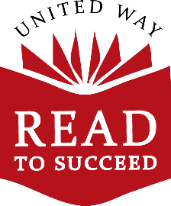
Conscious Discipline Progress Assessment Rubric

Mid-year Report - 2020
Center: ___________________________________

Please answer the following questions.
- In your infant rooms:
  - What are you most excited about?
  - What are your goals?
  - Who will be responsible for supporting work towards these goals?
  - What supports do you need to reach these goals?
- In your toddler rooms:
  - What are you most excited about?
  - What are your goals?
  - Who will be responsible for supporting work towards these goals?
  - What supports do you need to reach these goals?
- In your 3s rooms:
  - What are you most excited about?
  - What are your goals?
  - Who will be responsible for supporting work towards these goals?
  - What supports do you need to reach these goals?
- In your 4s rooms:
  - What are you most excited about?
  - What are your goals?
  - Who will be responsible for supporting work towards these goals?
  - What supports do you need to reach these goals?

