How do I access the MyTeachingStrategies® Practice Environment?
In the MyTeachingStrategies® Practice Environment, you can explore, learn, and hone your skills using the MyTeachingStrategies® platform and the GOLD® assessment tool without making changes to your live account. Feel free to explore areas, test features, and learn more about how to use your MyTeachingStrategies® account. Remember that this is a practice area, and none of the information or changes entered here will be saved in or transferred to your live account.
Registering for the Practice Environment
You must first register for the MyTeachingStrategies® Practice Environment.
- Select Register For Practice Environment from the Profile icon dropdown (1).
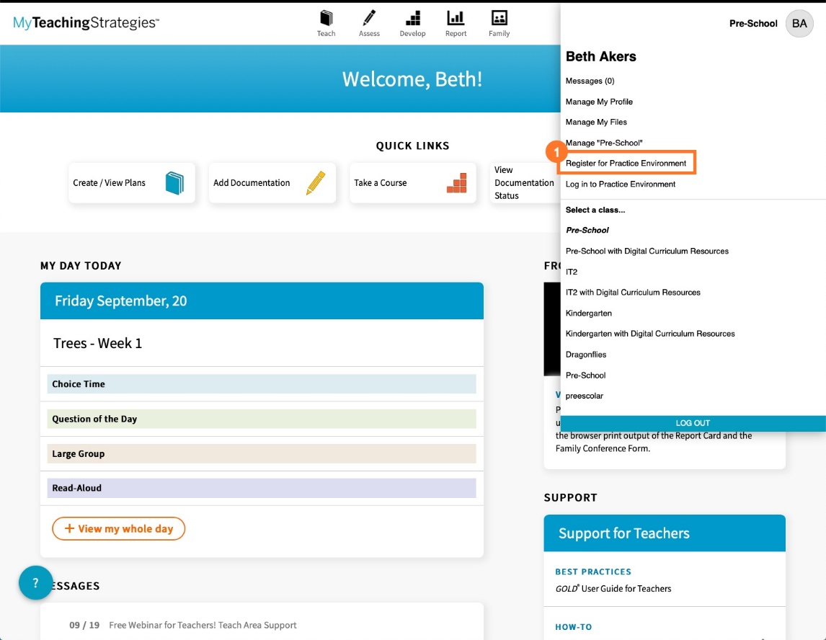

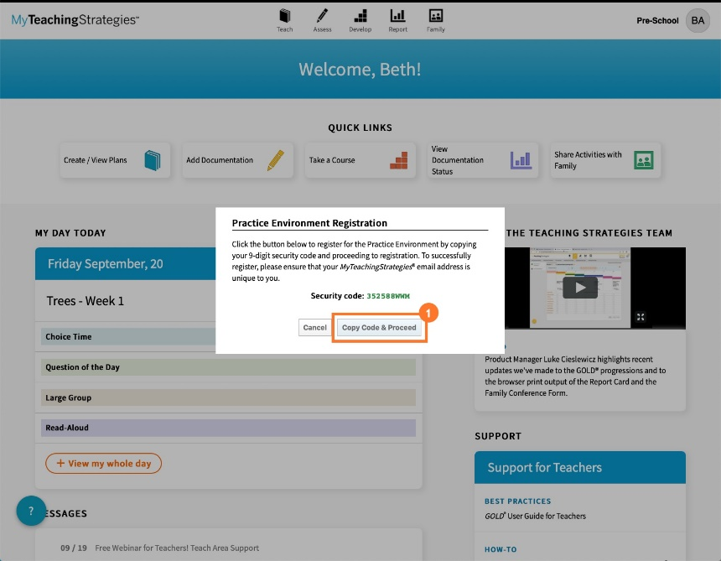
- Select Copy Code & Proceed to copy a unique security code into the registration page (1).

- Type in your First Name and Last Name (1).
- The email address associated with your account is copied into the email field (2).
- Create a unique Username and Password for the Practice Environment (3). The username can be the same as your MyTeachingStrategies® username as long as it is not already in use. The password must be at least six characters long, including one lower- case letter, one upper-case letter, and one number.
- The Security Code is copied into the Security Code field (4).
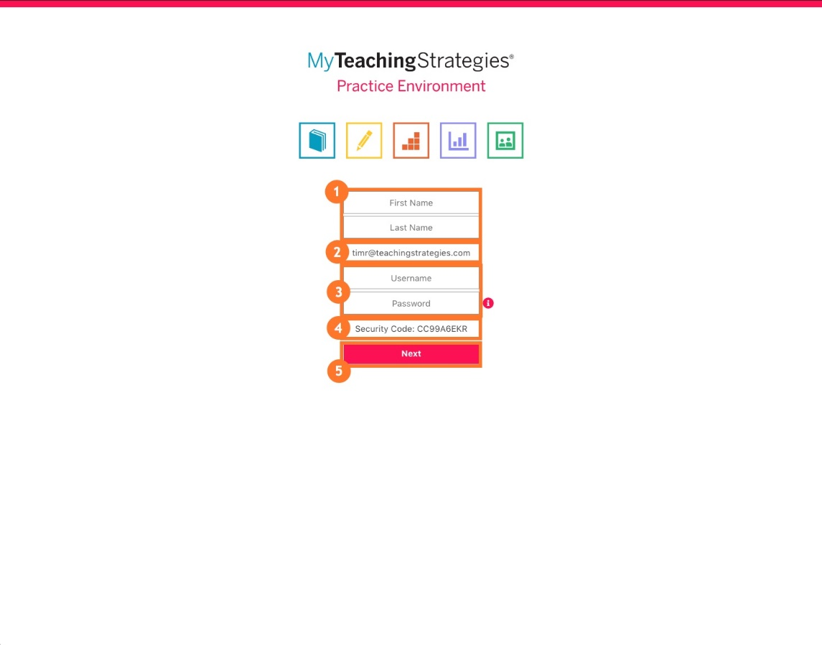
- Select Next (5).

- Choose to populate your Practice Environment account with a sample Infants Toddlers & Twos class, a sample Preschool class, and/or a sample Kindergarten class (1).
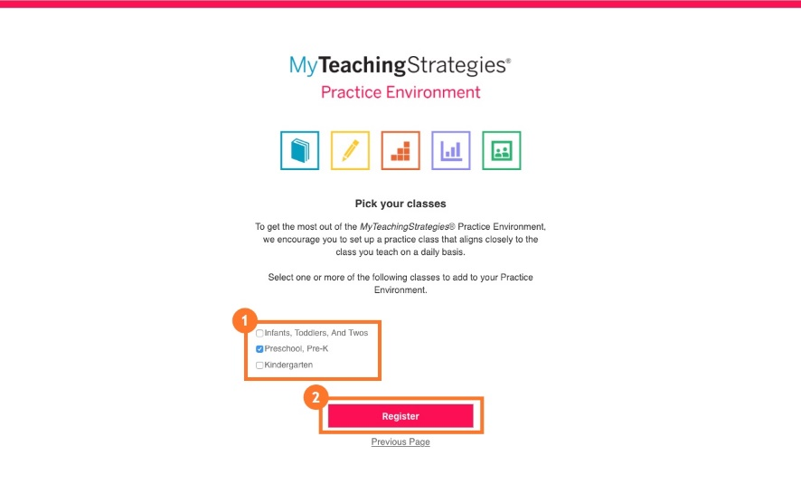
- Select Register (2).

You will then access the About page.
- Review the welcome message, then select Close (1).
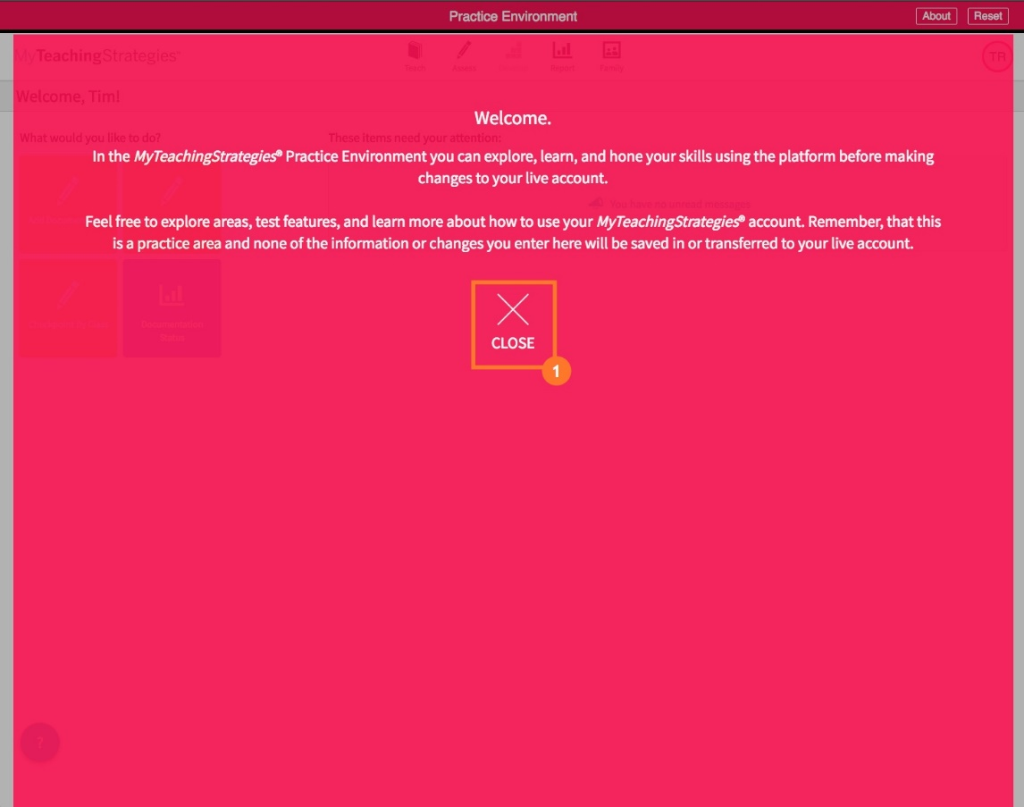

You are now able to explore the MyTeachingStrategies® Practice Environment!
Please note that the features in the Teach area, Develop area, and the Family area are not currently accessible in the Practice Environment.
- Select the Assess area to practice adding documentation and entering checkpoint ratings (1). For more information on practicing entering checkpoint ratings, please review this article: How do I practice entering checkpoint ratings in the MyTeachingStrategies® Practice Environment?
- Select the Report area to practice generating reports (2). For more information on practicing generating reports, please review this article: How do I practice generating reports in the MyTeachingStrategies® Practice Environment?
- If you need to reset your Practice Environment, select Reset (3).
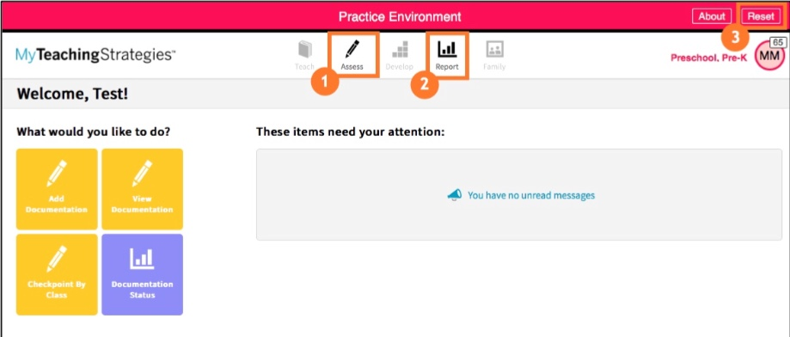

Accessing the Practice Environment
To access the MyTeachingStrategies® Practice Environment again after registering:
- Select Log In To Practice Environment from your MyTeachingStrategies® profile (1).
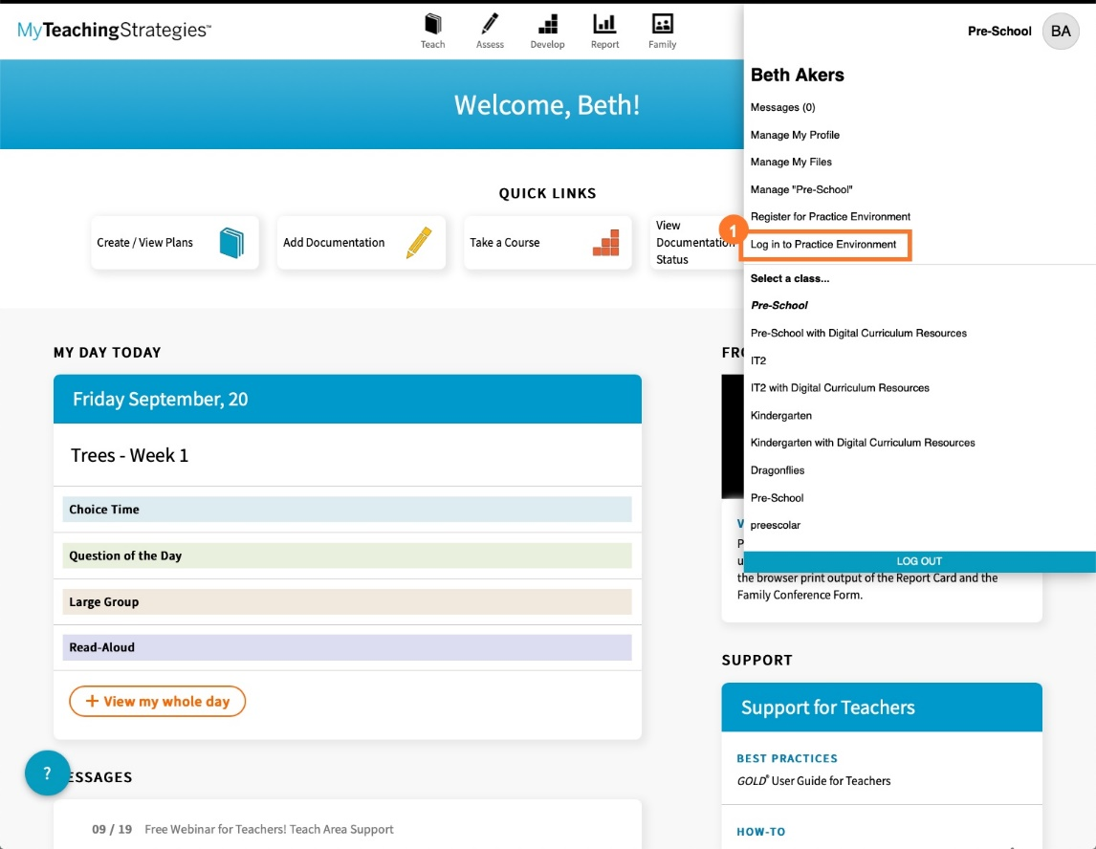
- Enter your Practice Environment username and password (1).
- Select Login (2).
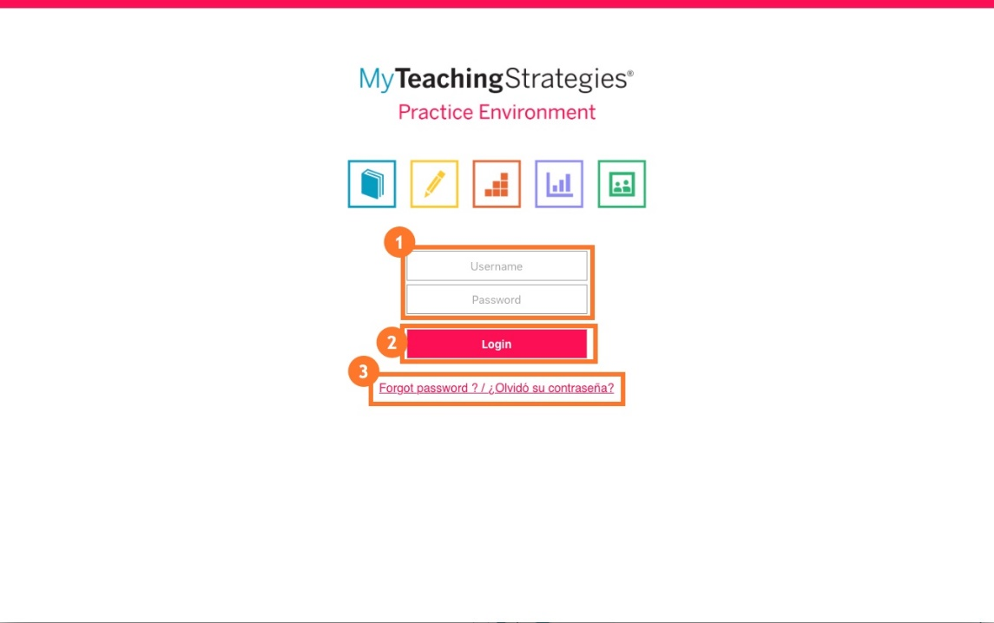
- If you forget your password, select Forgot Password? (3).

