How do I add GOLD® documentation in MyTeachingStrategies®?
Primary teachers, co-teachers, assistant teachers, and team members using GOLD® can add documentation of children's knowledge, skills, and abilities to MyTeachingStrategies® either on the MyTeachingStrategies® web platform, or via the GOLD® Documentation mobile app.
To add GOLD® documentation to MyTeachingStrategies®:
- While in the Assess area (1), select Add Documentation (2). For more information on what should be included in documentation, please review this article: What type of information should be included in GOLD® documentation?
- Choose a date observed (3), which is when you observed the knowledge, skills, and abilities of the child or children in the documentation.
- Select the child(ren) who were observed (4). For more information, please review this article: How do I add GOLD® documentation for more than one child at a time in MyTeachingStrategies®?
- Choose a Documentation Type (General Documentation is selected by default) (5). For more information on the Documentation Type selections, please review this article: What options can i select from the Documentation Type drop-down box on the Add Documentation page in MyTeachingStrategies®?
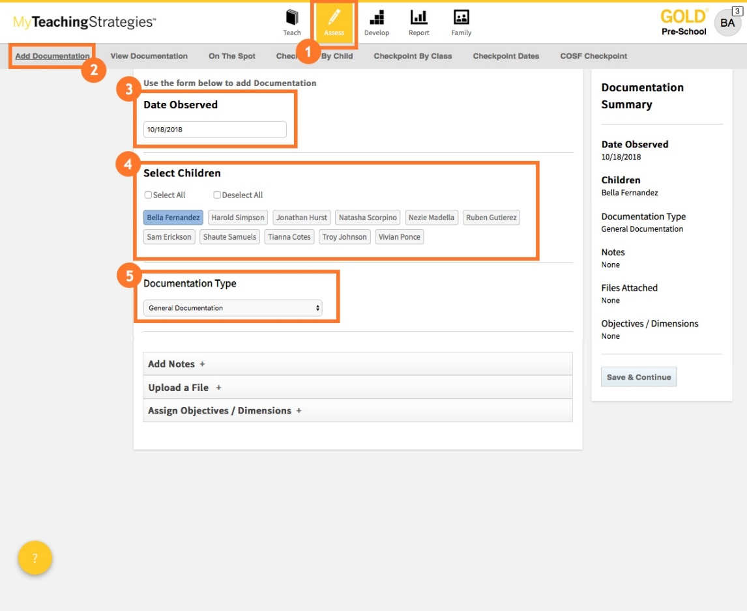

- If your documentation includes an observation note, select Add Notes and type in the note (1). For more information on best practices for collecting observation notes, please review this article: What are the best practices for collecting GOLD® documentation?
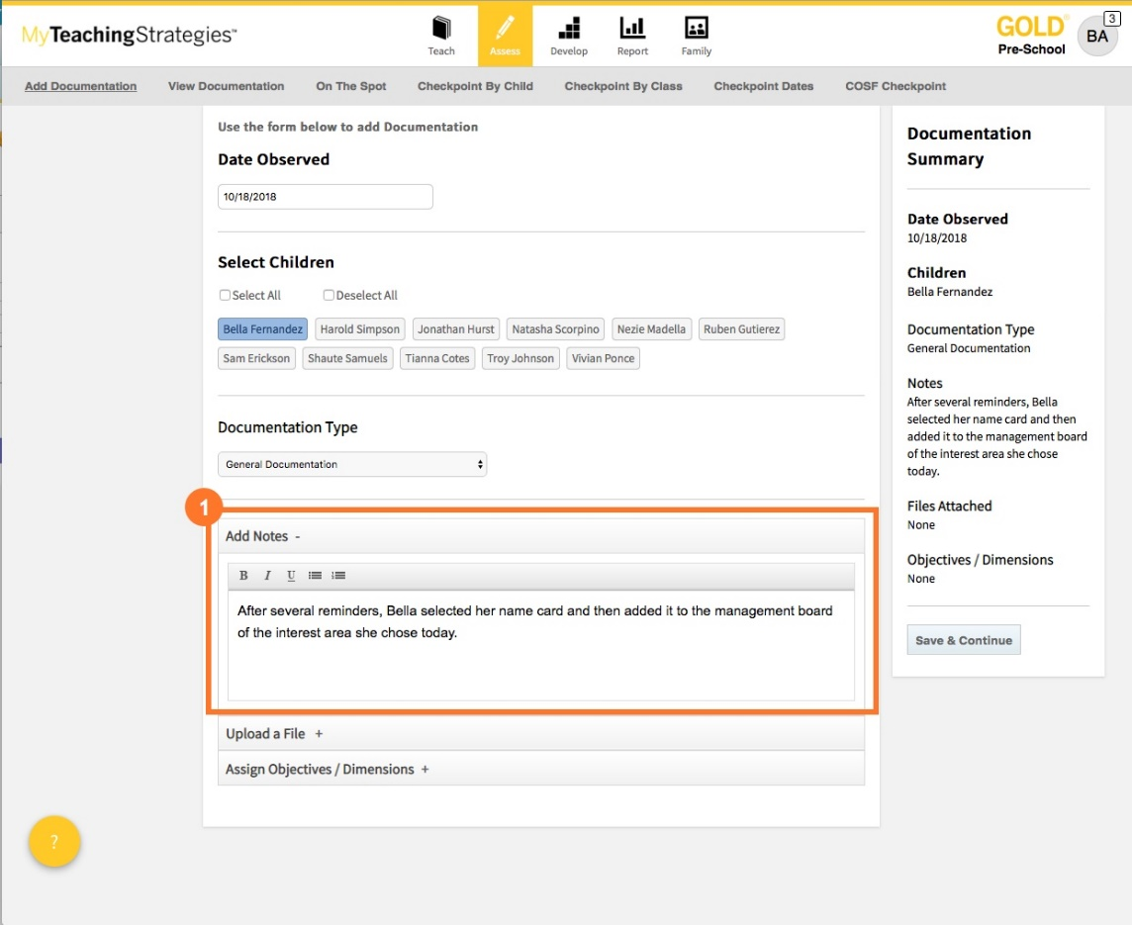
- If your documentation includes a file, such as a picture, video, or sample of classroom work, select Upload a File (1).
- Select Add File to select a file from your device (2). You can upload JPG or PNG picture files, MP3 audio files, MPEG or MP4 video files, or Microsoft Word or PDF documents. There is a 100MB size limit for video files and a 5MB size limit for other files.
- Once the file is uploaded, a thumbnail of the file will appear (3).
- You also have the option to add a caption to your uploaded file (4).
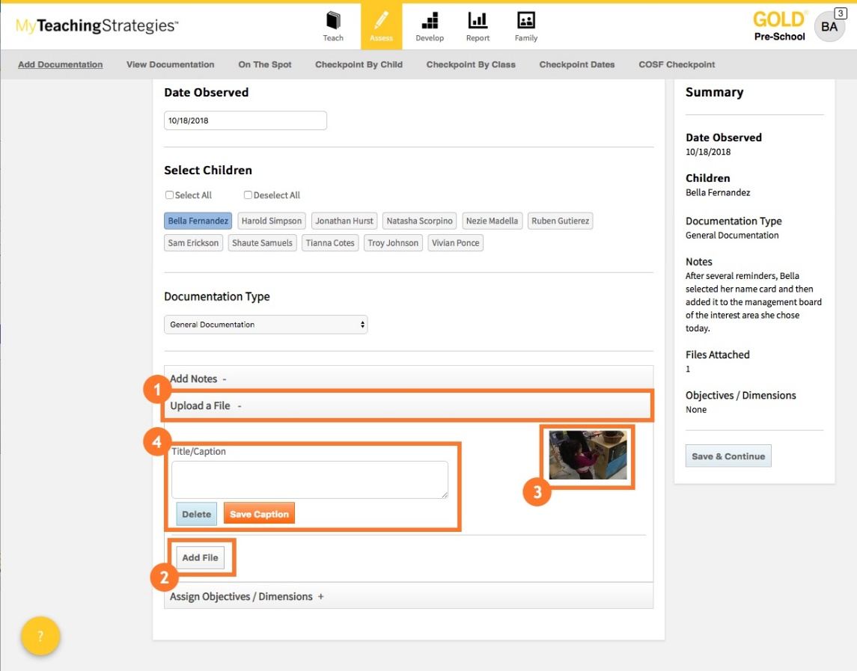
- Select Assign Objectives/Dimensions to tag objectives/dimensions to the documentation (1).
- Toggle between the areas of development and learning (2), then select any objectives/dimensions the selected child or children demonstrated in the documentation (3). For more information on the suggested number of objectives/dimensions to tag to one documentation, please review the following article: What are the best practices for collecting GOLD® documentation?
- You can preview the progressions for the objectives/dimensions to help choose which objectives/dimensions most closely match the knowledge, skills, and abilities demonstrated in the documentation (4).
- Select Save & Continue (5).
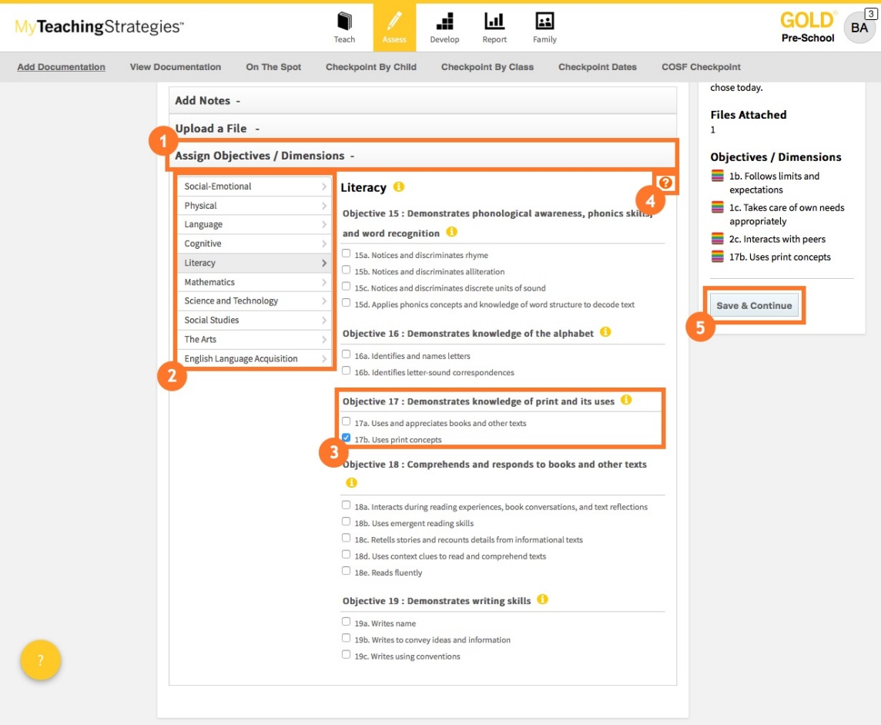
You will then be prompted to enter preliminary levels for the tagged objectives/dimensions. For more information, please review this article: When should I enter preliminary levels to GOLD® documentation?
- Select the level that best matches the knowledge, skills, and abilities that were demonstrated in the documentation (1).
- Select Next (2) to save and move to the next tagged objective/dimension or Save & Close (3) to save and navigate away from the documentation.
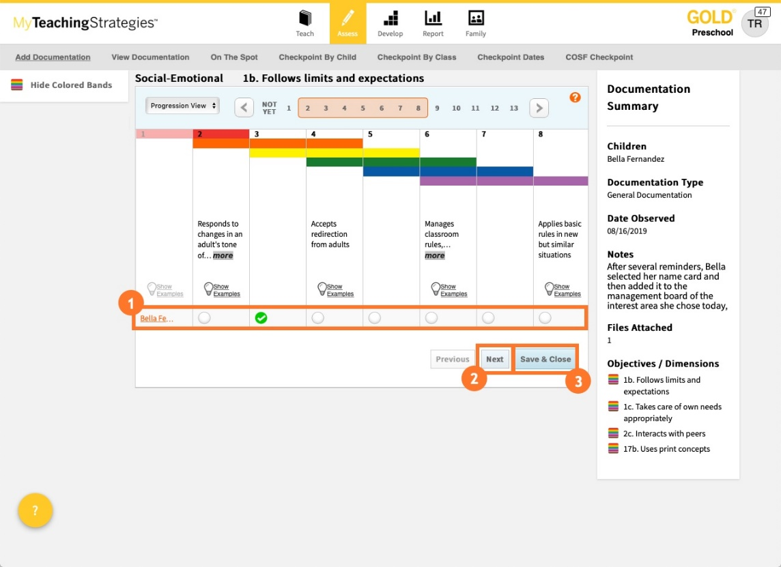
- Select View Documentation (1) to view the documentation you have just added or select Add Another (2) to add another piece of documentation. For more information on viewing the documentation you have added, please review this article: How do I view documentation as a teacher in MyTeachingStrategies®?
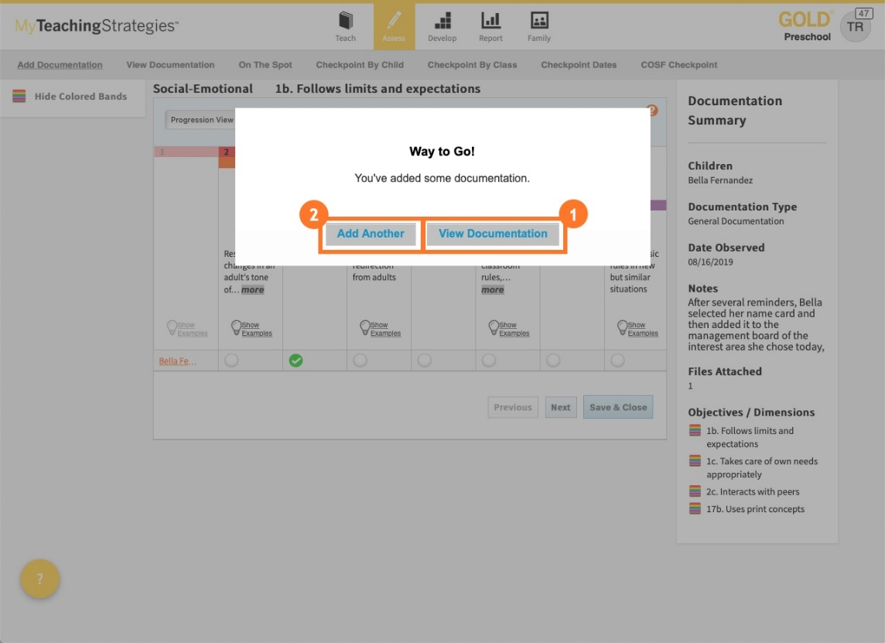
For more information on using the GOLD® Documentation mobile app, please review these articles: How do I add documentation with the GOLD® Documentation app using an iOS device? and How do I add documentation with the GOLD® Documentation app using an Android device?

