GOLD Collection Checklist
Room/Age: ____________________Teacher Collecting: ___________________
Objective: 8b – follows directions
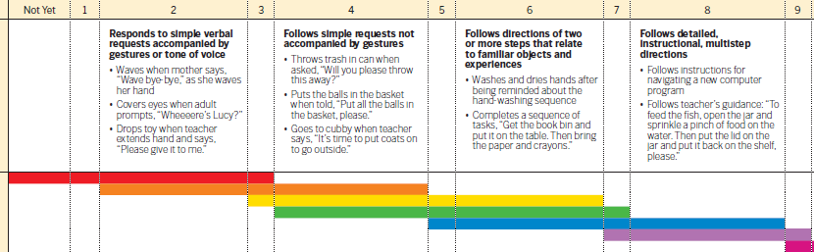
Levels for this age: ___________________________________________________
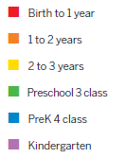

Activity: ___________________________________________________________
Student Name |  |  |  |  | Ab | Notes

