GOLD Collection Checklist
Room/Age: ____________________Teacher Collecting: ___________________
Objective: 2d – Makes friends
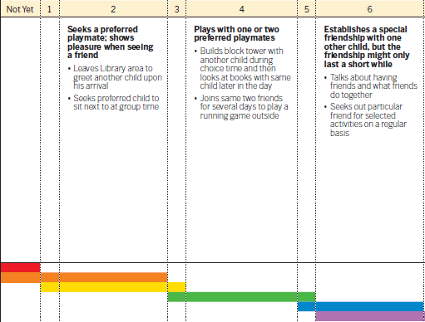
Levels for this age: ___________________________________________________

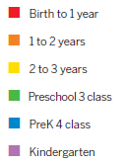

Activity: ___________________________________________________________
Student Name |  |  |  |  | Ab | Notes

