GOLD Collection Checklist
Room/Age: ____________________Teacher Collecting: ___________________
Objective: 19a – Writes name
Levels for this age: ___________________________________________________
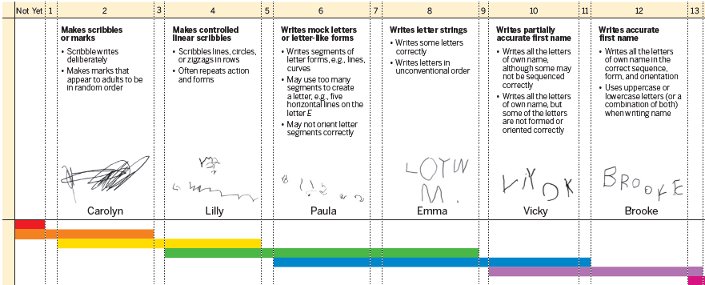

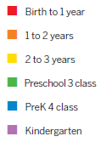

Activity: ___________________________________________________________
Student Name |  |  |  |  | Ab | Notes

