GOLD Collection Checklist
Room/Age: ____________________Teacher Collecting: ___________________
Objective: 18a – Interacts during reading experiences, book conversations, and text reflections
Levels for this age: ___________________________________________________
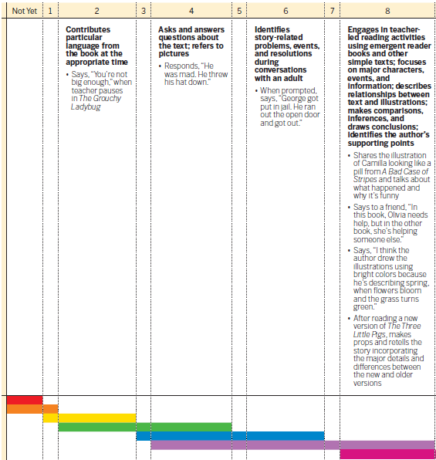

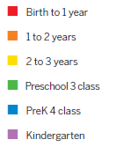

Activity: ___________________________________________________________
Student Name |  |  |  |  | Ab | Notes

